Batch size 128 / 128 , Learning rate 0.1

#0 Loss: 3.5185 Acc: 12.4583% Time: 45.2186s

[Test Phase] Loss: 521.7266 Acc: 3.3333% Time: 47.6758s

#1 Loss: 3.4190 Acc: 4.7424% Time: 91.4846s

[Test Phase] Loss: 3.4012 Acc: 6.3333% Time: 94.2153s

#2 Loss: 3.2993 Acc: 7.1392% Time: 139.8274s

[Test Phase] Loss: 3.3358 Acc: 7.6667% Time: 142.2018s

#3 Loss: 3.2147 Acc: 9.5232% Time: 185.4348s

[Test Phase] Loss: 3.2055 Acc: 9.0000% Time: 188.1546s

#4 Loss: 3.1094 Acc: 11.3304% Time: 233.0531s

[Test Phase] Loss: 3.3007 Acc: 6.6667% Time: 235.4796s

#5 Loss: 3.0029 Acc: 14.2015% Time: 281.9810s

[Test Phase] Loss: 2.8716 Acc: 14.3333% Time: 284.4231s

#6 Loss: 2.8618 Acc: 16.3035% Time: 328.9794s

[Test Phase] Loss: 2.7416 Acc: 14.6667% Time: 331.7466s

#7 Loss: 2.7159 Acc: 19.1618% Time: 377.2123s

[Test Phase] Loss: 3.0156 Acc: 17.0000% Time: 379.9596s

#8 Loss: 2.5230 Acc: 24.7885% Time: 426.2347s

[Test Phase] Loss: 2.3608 Acc: 24.3333% Time: 429.0452s

#9 Loss: 2.3153 Acc: 30.0820% Time: 472.7847s

[Test Phase] Loss: 1.9888 Acc: 36.3333% Time: 475.3145s

#10 Loss: 2.1448 Acc: 34.4014% Time: 518.6315s

[Test Phase] Loss: 2.3793 Acc: 29.6667% Time: 521.3257s

#11 Loss: 1.9517 Acc: 40.1436% Time: 565.2495s

[Test Phase] Loss: 2.0924 Acc: 30.3333% Time: 567.9428s

#12 Loss: 1.7874 Acc: 44.7449% Time: 616.8053s

[Test Phase] Loss: 1.7327 Acc: 44.0000% Time: 619.4796s

#13 Loss: 1.6176 Acc: 49.7308% Time: 663.6047s

[Test Phase] Loss: 4.1131 Acc: 17.0000% Time: 666.2256s

#14 Loss: 1.4822 Acc: 53.7298% Time: 711.7120s

[Test Phase] Loss: 1.6283 Acc: 52.0000% Time: 714.4170s

#15 Loss: 1.3289 Acc: 58.3184% Time: 756.1463s

[Test Phase] Loss: 1.8201 Acc: 49.0000% Time: 758.7351s

#16 Loss: 1.2000 Acc: 61.7021% Time: 802.0092s

[Test Phase] Loss: 1.6623 Acc: 52.0000% Time: 804.5162s

#17 Loss: 1.0662 Acc: 66.6624% Time: 850.2229s

[Test Phase] Loss: 1.6774 Acc: 54.6667% Time: 852.7858s

#18 Loss: 0.9661 Acc: 70.0846% Time: 897.6471s

[Test Phase] Loss: 1.5876 Acc: 55.0000% Time: 900.1364s

#19 Loss: 0.8620 Acc: 73.3914% Time: 947.9558s

[Test Phase] Loss: 1.4676 Acc: 59.0000% Time: 950.7107s

#20 Loss: 0.7389 Acc: 76.2753% Time: 998.4641s

[Test Phase] Loss: 1.5261 Acc: 59.6667% Time: 1001.3742s

#21 Loss: 0.6163 Acc: 80.3640% Time: 1046.2935s

[Test Phase] Loss: 1.4661 Acc: 63.3333% Time: 1048.7716s

#22 Loss: 0.5565 Acc: 82.4917% Time: 1094.7650s

[Test Phase] Loss: 1.4362 Acc: 64.3333% Time: 1097.1423s

#23 Loss: 0.4144 Acc: 86.6060% Time: 1147.0172s

[Test Phase] Loss: 1.9189 Acc: 54.0000% Time: 1150.1188s

#24 Loss: 0.3855 Acc: 87.5288% Time: 1201.5230s

[Test Phase] Loss: 1.8280 Acc: 58.3333% Time: 1204.1823s

#25 Loss: 0.3352 Acc: 89.2464% Time: 1249.0065s

[Test Phase] Loss: 1.2712 Acc: 69.6667% Time: 1251.9539s

#26 Loss: 0.2454 Acc: 92.2840% Time: 1303.3340s

[Test Phase] Loss: 1.5088 Acc: 68.3333% Time: 1306.1328s

#27 Loss: 0.2028 Acc: 93.4119% Time: 1357.5153s

[Test Phase] Loss: 1.6387 Acc: 68.0000% Time: 1360.4305s

#28 Loss: 0.1536 Acc: 95.2448% Time: 1405.8356s

[Test Phase] Loss: 5.7922 Acc: 36.3333% Time: 1408.5985s

29 Loss: 0.1484 Acc: 95.6293% Time: 1453.2001s

[Test Phase] Loss: 1.4340 Acc: 70.6667% Time: 1455.8238s

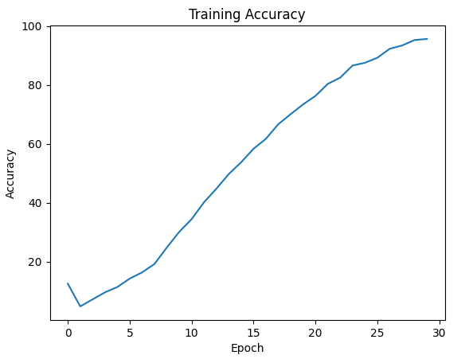 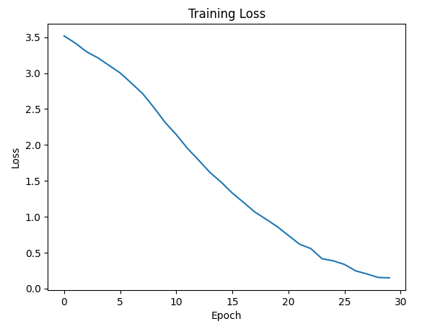 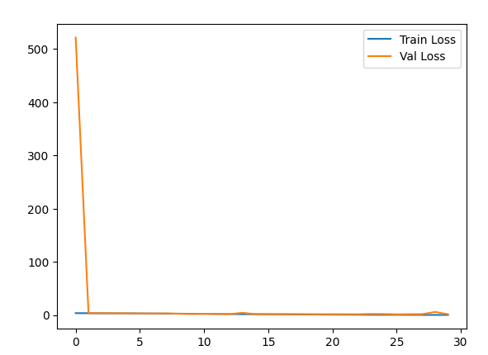

Batch size 128 / 128 , Learning rate 0.01

#0 Loss: 1.9598 Acc: 44.7834% Time: 61.7311s

[Test Phase] Loss: 0.8118 Acc: 71.3333% Time: 65.9015s

#1 Loss: 0.6010 Acc: 81.8252% Time: 129.1381s

[Test Phase] Loss: 0.5866 Acc: 80.0000% Time: 133.0013s

#2 Loss: 0.2715 Acc: 92.2584% Time: 193.7889s

[Test Phase] Loss: 0.5350 Acc: 82.0000% Time: 197.7583s

#3 Loss: 0.1306 Acc: 96.7444% Time: 260.2790s

[Test Phase] Loss: 0.3995 Acc: 86.0000% Time: 264.1775s

#4 Loss: 0.0649 Acc: 98.6157% Time: 319.4618s

[Test Phase] Loss: 0.4466 Acc: 86.3333% Time: 322.3387s

#5 Loss: 0.0380 Acc: 99.2438% Time: 363.2054s

[Test Phase] Loss: 0.4314 Acc: 87.6667% Time: 366.3751s

#6 Loss: 0.0232 Acc: 99.5514% Time: 418.0280s

[Test Phase] Loss: 0.3913 Acc: 88.6667% Time: 421.0001s

#7 Loss: 0.0121 Acc: 99.8077% Time: 471.1357s

[Test Phase] Loss: 0.3763 Acc: 89.0000% Time: 473.7084s

#8 Loss: 0.0071 Acc: 99.9231% Time: 513.9360s

[Test Phase] Loss: 0.3452 Acc: 89.0000% Time: 516.4965s

#9 Loss: 0.0050 Acc: 99.9231% Time: 558.5702s

[Test Phase] Loss: 0.3677 Acc: 89.3333% Time: 560.9793s

#10 Loss: 0.0051 Acc: 99.8975% Time: 600.4568s

[Test Phase] Loss: 0.3531 Acc: 90.0000% Time: 603.0352s

#11 Loss: 0.0032 Acc: 99.9487% Time: 644.1627s

[Test Phase] Loss: 0.3372 Acc: 90.6667% Time: 646.6941s

#12 Loss: 0.0030 Acc: 99.9359% Time: 688.7892s

[Test Phase] Loss: 0.3352 Acc: 90.0000% Time: 691.4654s

#13 Loss: 0.0031 Acc: 99.9359% Time: 732.0323s

[Test Phase] Loss: 0.3467 Acc: 90.3333% Time: 734.7107s

#14 Loss: 0.0029 Acc: 99.9615% Time: 775.8812s

[Test Phase] Loss: 0.3412 Acc: 90.3333% Time: 778.4192s

#15 Loss: 0.0022 Acc: 99.9487% Time: 822.0679s

[Test Phase] Loss: 0.3476 Acc: 90.3333% Time: 824.5774s

#16 Loss: 0.0019 Acc: 99.9359% Time: 866.2439s

[Test Phase] Loss: 0.3428 Acc: 91.0000% Time: 869.2667s

#17 Loss: 0.0016 Acc: 99.9744% Time: 912.2052s

[Test Phase] Loss: 0.3379 Acc: 90.3333% Time: 914.8319s

#18 Loss: 0.0022 Acc: 99.9359% Time: 956.0778s

[Test Phase] Loss: 0.3512 Acc: 90.3333% Time: 958.7085s

#19 Loss: 0.0016 Acc: 99.9744% Time: 1000.4622s

[Test Phase] Loss: 0.3403 Acc: 91.0000% Time: 1003.4949s

#20 Loss: 0.0017 Acc: 99.9487% Time: 1044.3293s

[Test Phase] Loss: 0.3582 Acc: 91.0000% Time: 1047.0641s

#21 Loss: 0.0016 Acc: 99.9487% Time: 1087.1580s

[Test Phase] Loss: 0.3522 Acc: 90.6667% Time: 1089.7324s

#22 Loss: 0.0012 Acc: 99.9744% Time: 1131.7779s

[Test Phase] Loss: 0.3490 Acc: 91.0000% Time: 1136.0508s

#23 Loss: 0.0014 Acc: 99.9615% Time: 1177.2031s

[Test Phase] Loss: 0.3573 Acc: 91.3333% Time: 1179.7624s

#24 Loss: 0.0014 Acc: 99.8718% Time: 1212.9209s

[Test Phase] Loss: 0.3626 Acc: 91.3333% Time: 1214.5418s

#25 Loss: 0.0014 Acc: 99.9487% Time: 1267.0703s

[Test Phase] Loss: 0.3677 Acc: 90.6667% Time: 1270.0872s

#26 Loss: 0.0014 Acc: 99.9487% Time: 1312.9135s

[Test Phase] Loss: 0.3555 Acc: 90.3333% Time: 1315.6925s

#27 Loss: 0.0013 Acc: 99.9359% Time: 1356.4469s

[Test Phase] Loss: 0.3493 Acc: 91.0000% Time: 1359.0505s

#28 Loss: 0.0010 Acc: 99.9744% Time: 1401.1918s

[Test Phase] Loss: 0.3654 Acc: 90.0000% Time: 1403.8505s

#29 Loss: 0.0014 Acc: 99.9487% Time: 1445.8688s

[Test Phase] Loss: 0.3526 Acc: 90.3333% Time: 1448.4653s

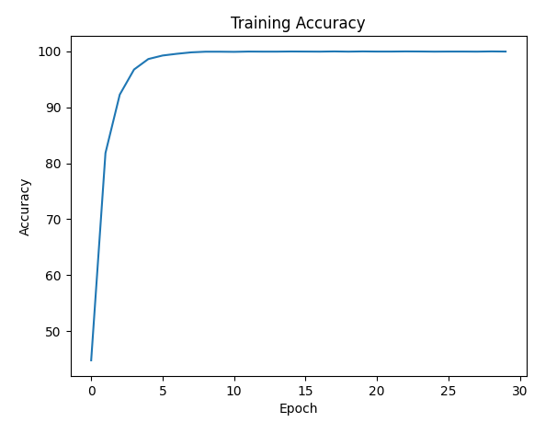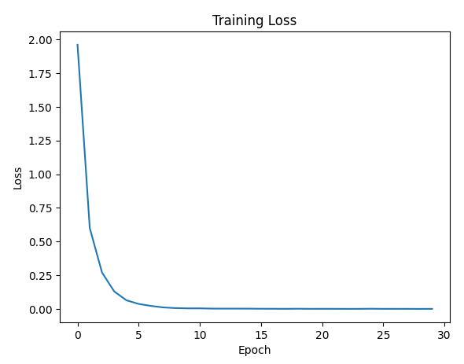

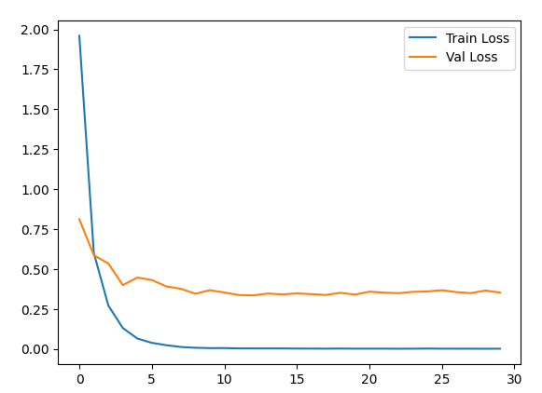

Batch size 128 / 128 , Learning rate 0.001

#0 Loss: 3.2019 Acc: 16.7906% Time: 40.9868s

[Test Phase] Loss: 2.8795 Acc: 32.3333% Time: 43.5343s

#1 Loss: 2.5087 Acc: 41.8098% Time: 87.7270s

[Test Phase] Loss: 2.0621 Acc: 46.6667% Time: 90.5202s

#2 Loss: 1.8614 Acc: 55.5242% Time: 132.5183s

[Test Phase] Loss: 1.5619 Acc: 64.0000% Time: 135.0556s

#3 Loss: 1.4276 Acc: 65.5473% Time: 178.3313s

[Test Phase] Loss: 1.2206 Acc: 72.0000% Time: 181.1952s

#4 Loss: 1.1200 Acc: 71.8790% Time: 227.2707s

[Test Phase] Loss: 0.9835 Acc: 74.3333% Time: 229.9079s

#5 Loss: 0.9092 Acc: 76.9674% Time: 272.6541s

[Test Phase] Loss: 0.8399 Acc: 76.6667% Time: 274.9817s

#6 Loss: 0.7497 Acc: 81.7483% Time: 317.2306s

[Test Phase] Loss: 0.7128 Acc: 79.3333% Time: 319.9510s

#7 Loss: 0.6228 Acc: 84.9654% Time: 363.1758s

[Test Phase] Loss: 0.6604 Acc: 80.3333% Time: 365.8842s

#8 Loss: 0.5165 Acc: 88.0287% Time: 417.9281s

[Test Phase] Loss: 0.6018 Acc: 82.0000% Time: 421.6927s

#9 Loss: 0.4264 Acc: 90.5922% Time: 486.6386s

[Test Phase] Loss: 0.5371 Acc: 82.3333% Time: 490.2118s

#10 Loss: 0.3538 Acc: 92.5532% Time: 550.3576s

[Test Phase] Loss: 0.5019 Acc: 83.3333% Time: 553.9814s

#11 Loss: 0.2984 Acc: 94.1041% Time: 620.3624s

[Test Phase] Loss: 0.4888 Acc: 84.0000% Time: 623.8452s

#12 Loss: 0.2441 Acc: 95.7062% Time: 685.9751s

[Test Phase] Loss: 0.4551 Acc: 85.6667% Time: 689.5994s

#13 Loss: 0.2004 Acc: 96.8341% Time: 749.3035s

[Test Phase] Loss: 0.4351 Acc: 86.3333% Time: 752.9398s

#14 Loss: 0.1645 Acc: 97.6801% Time: 816.2656s

[Test Phase] Loss: 0.4380 Acc: 87.3333% Time: 819.7869s

#15 Loss: 0.1399 Acc: 98.1415% Time: 880.5831s

[Test Phase] Loss: 0.4222 Acc: 88.3333% Time: 884.1542s

#16 Loss: 0.1141 Acc: 98.7439% Time: 947.4106s

[Test Phase] Loss: 0.4261 Acc: 87.6667% Time: 950.8456s

#17 Loss: 0.0968 Acc: 99.0131% Time: 1014.2962s

[Test Phase] Loss: 0.4043 Acc: 88.3333% Time: 1017.6801s

#18 Loss: 0.0802 Acc: 99.3463% Time: 1081.0112s

[Test Phase] Loss: 0.4070 Acc: 87.0000% Time: 1084.9799s

#19 Loss: 0.0689 Acc: 99.3591% Time: 1138.5556s

[Test Phase] Loss: 0.4107 Acc: 87.6667% Time: 1141.1327s

#20 Loss: 0.0597 Acc: 99.5899% Time: 1184.2559s

[Test Phase] Loss: 0.3992 Acc: 88.0000% Time: 1186.7310s

#21 Loss: 0.0509 Acc: 99.6539% Time: 1234.1796s

[Test Phase] Loss: 0.4074 Acc: 88.0000% Time: 1236.8528s

#22 Loss: 0.0447 Acc: 99.7821% Time: 1282.3921s

[Test Phase] Loss: 0.4096 Acc: 87.6667% Time: 1285.0992s

#23 Loss: 0.0381 Acc: 99.8462% Time: 1332.0580s

[Test Phase] Loss: 0.4059 Acc: 88.3333% Time: 1334.7867s

#24 Loss: 0.0338 Acc: 99.8718% Time: 1380.9209s

[Test Phase] Loss: 0.4014 Acc: 88.3333% Time: 1383.5418s

#25 Loss: 0.0313 Acc: 99.8846% Time: 1428.5794s

[Test Phase] Loss: 0.4016 Acc: 87.3333% Time: 1431.7107s

#26 Loss: 0.0281 Acc: 99.8846% Time: 1475.8533s

[Test Phase] Loss: 0.4016 Acc: 88.6667% Time: 1478.5419s

#27 Loss: 0.0257 Acc: 99.9359% Time: 1524.2086s

[Test Phase] Loss: 0.4053 Acc: 87.3333% Time: 1526.7982s

#28 Loss: 0.0236 Acc: 99.9359% Time: 1574.6269s

[Test Phase] Loss: 0.4035 Acc: 88.6667% Time: 1578.5151s

#29 Loss: 0.0212 Acc: 99.8975% Time: 1623.6644s

[Test Phase] Loss: 0.4016 Acc: 87.3333% Time: 1626.4959s

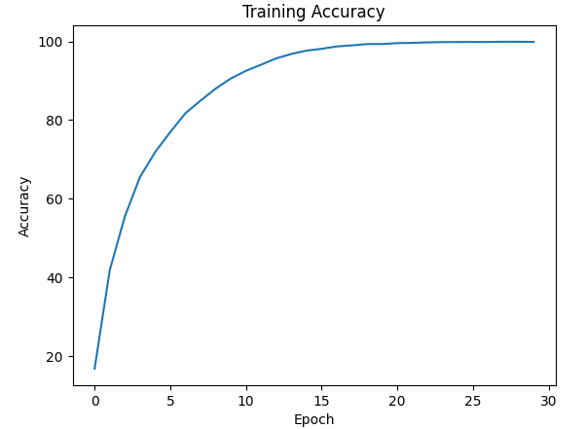 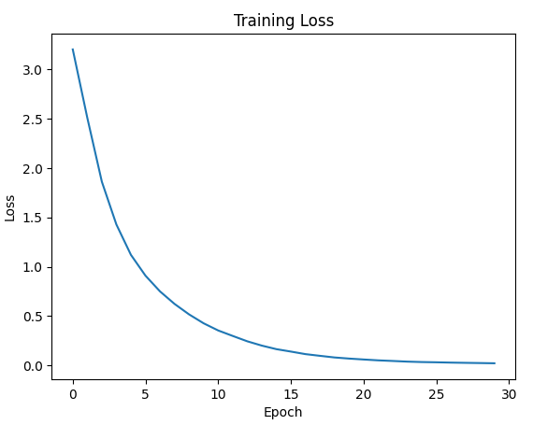 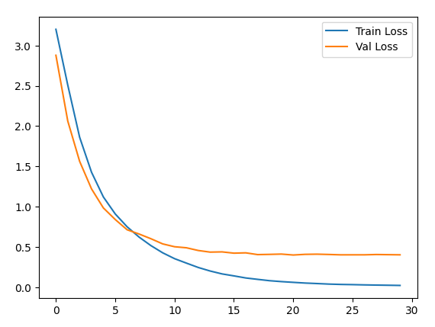

Batch size 32 / 32 , Learning rate 0.01

#0 Loss: 1.7227 Acc: 48.8465% Time: 43.3883s

[Test Phase] Loss: 1.5478 Acc: 54.3333% Time: 45.4315s

#1 Loss: 0.9740 Acc: 70.0077% Time: 91.9475s

[Test Phase] Loss: 0.8185 Acc: 71.3333% Time: 94.0760s

#2 Loss: 0.6699 Acc: 78.9798% Time: 140.7777s

[Test Phase] Loss: 0.9077 Acc: 72.6667% Time: 142.7543s

#3 Loss: 0.4922 Acc: 84.2733% Time: 188.7806s

[Test Phase] Loss: 0.7249 Acc: 76.6667% Time: 190.7088s

#4 Loss: 0.3857 Acc: 87.9646% Time: 235.3303s

[Test Phase] Loss: 0.9017 Acc: 76.0000% Time: 237.2509s

#5 Loss: 0.2813 Acc: 91.4253% Time: 283.5104s

[Test Phase] Loss: 0.6476 Acc: 80.6667% Time: 285.4600s

#6 Loss: 0.2208 Acc: 93.0146% Time: 336.9595s

[Test Phase] Loss: 0.7444 Acc: 80.0000% Time: 339.6139s

#7 Loss: 0.1720 Acc: 94.8218% Time: 403.9992s

[Test Phase] Loss: 0.6462 Acc: 83.6667% Time: 406.5114s

#8 Loss: 0.1430 Acc: 95.3730% Time: 469.2508s

[Test Phase] Loss: 0.6664 Acc: 82.3333% Time: 472.3544s

#9 Loss: 0.1300 Acc: 96.0651% Time: 536.3818s

[Test Phase] Loss: 0.7032 Acc: 83.6667% Time: 539.5731s

#10 Loss: 0.0987 Acc: 96.9880% Time: 604.1838s

[Test Phase] Loss: 0.6668 Acc: 81.6667% Time: 607.0780s

#11 Loss: 0.0848 Acc: 97.3340% Time: 674.2903s

[Test Phase] Loss: 0.9118 Acc: 81.6667% Time: 677.1347s

#12 Loss: 0.0529 Acc: 98.4235% Time: 740.8624s

[Test Phase] Loss: 0.7434 Acc: 86.0000% Time: 743.5266s

#13 Loss: 0.0378 Acc: 98.8080% Time: 809.8528s

[Test Phase] Loss: 0.5907 Acc: 86.0000% Time: 812.6666s

#14 Loss: 0.0514 Acc: 98.4876% Time: 878.7617s

[Test Phase] Loss: 0.6546 Acc: 83.3333% Time: 881.7307s

#15 Loss: 0.0447 Acc: 98.5901% Time: 951.2032s

[Test Phase] Loss: 0.5633 Acc: 87.6667% Time: 954.1751s

#16 Loss: 0.0533 Acc: 98.1671% Time: 1021.0550s

[Test Phase] Loss: 0.7491 Acc: 84.0000% Time: 1024.0338s

#17 Loss: 0.0355 Acc: 98.9105% Time: 1077.8010s

[Test Phase] Loss: 0.5525 Acc: 87.3333% Time: 1080.2694s

#18 Loss: 0.0215 Acc: 99.3976% Time: 1127.0923s

[Test Phase] Loss: 0.6825 Acc: 85.6667% Time: 1129.2952s

#19 Loss: 0.0145 Acc: 99.5642% Time: 1177.6683s

[Test Phase] Loss: 0.5821 Acc: 87.6667% Time: 1179.7355s

#20 Loss: 0.0080 Acc: 99.8077% Time: 1229.1162s

[Test Phase] Loss: 0.5175 Acc: 89.3333% Time: 1231.1584s

#21 Loss: 0.0044 Acc: 99.9103% Time: 1281.3255s

[Test Phase] Loss: 0.5093 Acc: 88.0000% Time: 1283.5289s

#22 Loss: 0.0031 Acc: 99.8846% Time: 1331.8341s

[Test Phase] Loss: 0.4823 Acc: 88.6667% Time: 1334.0757s

#23 Loss: 0.0031 Acc: 99.9103% Time: 1384.1617s

[Test Phase] Loss: 0.5833 Acc: 88.0000% Time: 1386.0683s

#24 Loss: 0.0041 Acc: 99.8846% Time: 1433.4163s

[Test Phase] Loss: 0.5201 Acc: 88.0000% Time: 1435.8120s

#25 Loss: 0.0029 Acc: 99.8975% Time: 1483.3144s

[Test Phase] Loss: 0.4951 Acc: 88.3333% Time: 1485.5147s

#26 Loss: 0.0023 Acc: 99.9487% Time: 1537.3193s

[Test Phase] Loss: 0.4852 Acc: 89.0000% Time: 1539.3313s

#27 Loss: 0.0031 Acc: 99.8975% Time: 1586.8929s

[Test Phase] Loss: 0.5352 Acc: 89.0000% Time: 1588.7091s

#28 Loss: 0.0030 Acc: 99.9103% Time: 1635.9193s

[Test Phase] Loss: 0.5626 Acc: 88.3333% Time: 1638.6084s

#29 Loss: 0.0022 Acc: 99.9359% Time: 1690.6839s

[Test Phase] Loss: 0.5743 Acc: 88.6667% Time: 1692.5867s

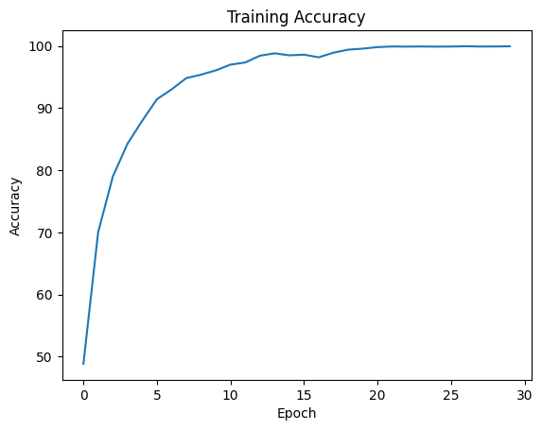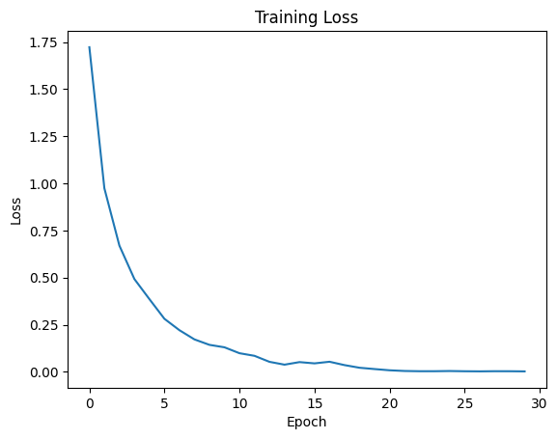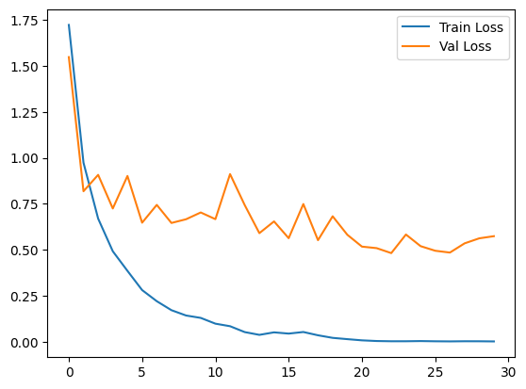

Batch size 32 / 32 , Learning rate 0.001

#0 Loss: 2.3708 Acc: 37.9646% Time: 50.2975s

[Test Phase] Loss: 1.2249 Acc: 65.3333% Time: 53.2485s

#1 Loss: 1.0436 Acc: 71.2894% Time: 106.0136s

[Test Phase] Loss: 0.6634 Acc: 78.6667% Time: 107.9836s

#2 Loss: 0.6057 Acc: 83.4017% Time: 155.5749s

[Test Phase] Loss: 0.4778 Acc: 86.6667% Time: 157.6913s

#3 Loss: 0.3778 Acc: 90.4127% Time: 202.3281s

[Test Phase] Loss: 0.3900 Acc: 87.3333% Time: 204.6805s

#4 Loss: 0.2378 Acc: 94.7065% Time: 249.4432s

[Test Phase] Loss: 0.3403 Acc: 89.6667% Time: 251.2155s

#5 Loss: 0.1477 Acc: 96.9495% Time: 295.8135s

[Test Phase] Loss: 0.3213 Acc: 90.3333% Time: 297.8145s

#6 Loss: 0.0954 Acc: 98.4363% Time: 342.3116s

[Test Phase] Loss: 0.2867 Acc: 90.6667% Time: 344.3186s

#7 Loss: 0.0593 Acc: 99.1797% Time: 389.4458s

[Test Phase] Loss: 0.2771 Acc: 92.3333% Time: 391.5002s

#8 Loss: 0.0498 Acc: 99.3335% Time: 436.8610s

[Test Phase] Loss: 0.2906 Acc: 92.0000% Time: 438.9756s

#9 Loss: 0.0335 Acc: 99.6283% Time: 483.5903s

[Test Phase] Loss: 0.2719 Acc: 92.0000% Time: 485.6749s

#10 Loss: 0.0275 Acc: 99.7437% Time: 533.4502s

[Test Phase] Loss: 0.2918 Acc: 91.6667% Time: 535.7443s

#11 Loss: 0.0221 Acc: 99.8206% Time: 580.1547s

[Test Phase] Loss: 0.2843 Acc: 92.3333% Time: 582.3438s

#12 Loss: 0.0182 Acc: 99.8334% Time: 629.9048s

[Test Phase] Loss: 0.2890 Acc: 91.6667% Time: 631.7453s

#13 Loss: 0.0148 Acc: 99.8846% Time: 677.8239s

[Test Phase] Loss: 0.2808 Acc: 92.0000% Time: 679.7684s

#14 Loss: 0.0128 Acc: 99.8975% Time: 726.5609s

[Test Phase] Loss: 0.2896 Acc: 91.3333% Time: 728.6171s

#15 Loss: 0.0119 Acc: 99.8846% Time: 775.4688s

[Test Phase] Loss: 0.3010 Acc: 90.6667% Time: 777.4801s

#16 Loss: 0.0105 Acc: 99.9103% Time: 821.1058s

[Test Phase] Loss: 0.2963 Acc: 91.6667% Time: 822.8740s

#17 Loss: 0.0092 Acc: 99.9615% Time: 867.3371s

[Test Phase] Loss: 0.2893 Acc: 91.3333% Time: 869.5621s

#18 Loss: 0.0079 Acc: 99.9231% Time: 919.1353s

[Test Phase] Loss: 0.3102 Acc: 90.6667% Time: 921.0307s

#19 Loss: 0.0087 Acc: 99.8975% Time: 966.0881s

[Test Phase] Loss: 0.3048 Acc: 91.0000% Time: 968.0563s

#20 Loss: 0.0087 Acc: 99.9231% Time: 1011.7435s

[Test Phase] Loss: 0.3091 Acc: 91.3333% Time: 1013.6322s

#21 Loss: 0.0066 Acc: 99.9744% Time: 1060.1817s

[Test Phase] Loss: 0.2996 Acc: 91.3333% Time: 1062.1505s

#22 Loss: 0.0063 Acc: 99.8975% Time: 1106.6230s

[Test Phase] Loss: 0.3266 Acc: 90.3333% Time: 1108.6489s

#23 Loss: 0.0060 Acc: 99.9615% Time: 1152.2297s

[Test Phase] Loss: 0.3155 Acc: 91.6667% Time: 1154.2463s

#24 Loss: 0.0053 Acc: 99.9487% Time: 1200.5026s

[Test Phase] Loss: 0.3109 Acc: 91.6667% Time: 1202.5074s

#25 Loss: 0.0052 Acc: 99.9359% Time: 1246.4067s

[Test Phase] Loss: 0.3293 Acc: 90.6667% Time: 1248.3144s

#26 Loss: 0.0053 Acc: 99.9359% Time: 1294.4933s

[Test Phase] Loss: 0.3142 Acc: 90.6667% Time: 1296.6937s

#27 Loss: 0.0047 Acc: 99.9615% Time: 1344.2625s

[Test Phase] Loss: 0.3152 Acc: 92.0000% Time: 1346.1574s

#28 Loss: 0.0049 Acc: 99.9359% Time: 1390.6208s

[Test Phase] Loss: 0.3056 Acc: 91.3333% Time: 1392.7669s

#29 Loss: 0.0045 Acc: 99.9359% Time: 1439.4286s

[Test Phase] Loss: 0.3246 Acc: 91.3333% Time: 1441.5606s

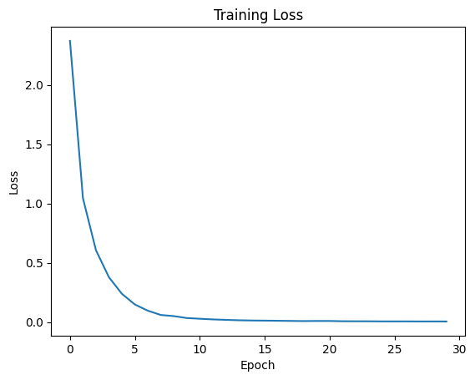

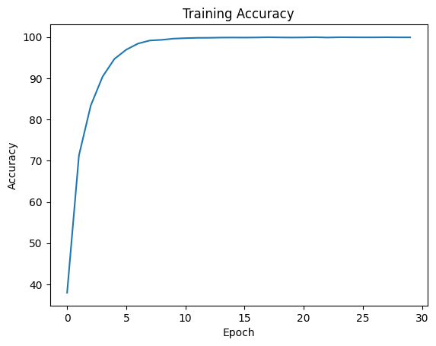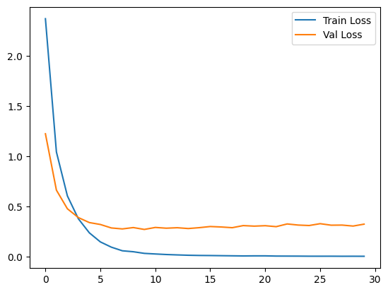

Batch size 32 / 32 , Learning rate 0.0001

#0 Loss: 3.3153 Acc: 9.3309% Time: 45.9891s

[Test Phase] Loss: 3.2165 Acc: 17.6667% Time: 47.9816s

#1 Loss: 3.0777 Acc: 25.0961% Time: 94.9385s

[Test Phase] Loss: 2.9438 Acc: 32.0000% Time: 96.9754s

#2 Loss: 2.8110 Acc: 35.0551% Time: 143.0700s

[Test Phase] Loss: 2.6066 Acc: 43.0000% Time: 145.0414s

#3 Loss: 2.5115 Acc: 41.8995% Time: 191.8160s

[Test Phase] Loss: 2.2765 Acc: 47.6667% Time: 193.9398s

#4 Loss: 2.2272 Acc: 48.4748% Time: 239.9444s

[Test Phase] Loss: 1.9920 Acc: 53.3333% Time: 242.3657s

#5 Loss: 1.9955 Acc: 53.2940% Time: 289.0325s

[Test Phase] Loss: 1.7766 Acc: 58.0000% Time: 290.9379s

#6 Loss: 1.7944 Acc: 57.9851% Time: 335.9814s

[Test Phase] Loss: 1.5913 Acc: 61.0000% Time: 337.9160s

#7 Loss: 1.6255 Acc: 60.8562% Time: 386.3633s

[Test Phase] Loss: 1.4121 Acc: 65.6667% Time: 388.4676s

#8 Loss: 1.4671 Acc: 64.4066% Time: 436.3719s

[Test Phase] Loss: 1.2668 Acc: 68.3333% Time: 438.5777s

#9 Loss: 1.3341 Acc: 67.8800% Time: 486.6321s

[Test Phase] Loss: 1.1479 Acc: 69.6667% Time: 488.7321s

#10 Loss: 1.2211 Acc: 69.1746% Time: 534.5440s

[Test Phase] Loss: 1.0714 Acc: 71.6667% Time: 536.5349s

#11 Loss: 1.1311 Acc: 71.6868% Time: 582.8981s

[Test Phase] Loss: 0.9854 Acc: 74.3333% Time: 584.8037s

#12 Loss: 1.0418 Acc: 74.0579% Time: 632.0403s

[Test Phase] Loss: 0.9161 Acc: 74.3333% Time: 634.0707s

#13 Loss: 0.9725 Acc: 75.7883% Time: 682.2504s

[Test Phase] Loss: 0.8548 Acc: 77.6667% Time: 684.2135s

#14 Loss: 0.8986 Acc: 77.9672% Time: 730.7840s

[Test Phase] Loss: 0.8121 Acc: 76.0000% Time: 732.7813s

#15 Loss: 0.8372 Acc: 79.1976% Time: 778.3601s

[Test Phase] Loss: 0.7595 Acc: 77.6667% Time: 780.5743s

#16 Loss: 0.7767 Acc: 80.5947% Time: 827.7574s

[Test Phase] Loss: 0.7263 Acc: 78.0000% Time: 829.6428s

#17 Loss: 0.7251 Acc: 82.4019% Time: 877.3635s

[Test Phase] Loss: 0.6971 Acc: 78.6667% Time: 879.5070s

#18 Loss: 0.6774 Acc: 83.5042% Time: 928.3399s

[Test Phase] Loss: 0.6574 Acc: 80.3333% Time: 930.3809s

#19 Loss: 0.6327 Acc: 84.9269% Time: 978.3210s

[Test Phase] Loss: 0.6311 Acc: 80.0000% Time: 980.2466s

#20 Loss: 0.5964 Acc: 86.0292% Time: 1030.3351s

[Test Phase] Loss: 0.6005 Acc: 80.6667% Time: 1032.4779s

#21 Loss: 0.5598 Acc: 86.7214% Time: 1079.7638s

[Test Phase] Loss: 0.5827 Acc: 82.6667% Time: 1082.1247s

#22 Loss: 0.5186 Acc: 88.0159% Time: 1131.0503s

[Test Phase] Loss: 0.5593 Acc: 83.3333% Time: 1134.2032s

#23 Loss: 0.4906 Acc: 89.1951% Time: 1186.7032s

[Test Phase] Loss: 0.5430 Acc: 84.0000% Time: 1188.7332s

#24 Loss: 0.4572 Acc: 89.6437% Time: 1240.8580s

[Test Phase] Loss: 0.5280 Acc: 84.3333% Time: 1242.9141s

#25 Loss: 0.4218 Acc: 90.7075% Time: 1294.5633s

[Test Phase] Loss: 0.5092 Acc: 85.0000% Time: 1297.3977s

#26 Loss: 0.4010 Acc: 91.4637% Time: 1347.8475s

[Test Phase] Loss: 0.4967 Acc: 85.0000% Time: 1350.6260s

#27 Loss: 0.3754 Acc: 92.0149% Time: 1399.2482s

[Test Phase] Loss: 0.4894 Acc: 85.0000% Time: 1401.1591s

#28 Loss: 0.3479 Acc: 92.9121% Time: 1448.5751s

[Test Phase] Loss: 0.4712 Acc: 86.6667% Time: 1450.4968s

#29 Loss: 0.3263 Acc: 93.5017% Time: 1497.4007s

[Test Phase] Loss: 0.4563 Acc: 86.6667% Time: 1499.5388s

